ASSIGNMENT – 5 (HTML) (KASHISH)

Q-1 Create an HTML file for a Flipkart-style product card and apply inline CSS to set a unique background color and font size for the product title only?
Ans.
<!DOCTYPE html>
<html lang="en">
<head>
<meta charset="UTF-8">
<meta name="viewport" content="width=device-width, initial-scale=1.0">
<title>Flipkart Product Card</title>
</head>
<body>
<div>
<img src="wireless headphone.jpeg"
alt=" Samsung Galaxy S24 Ultra" width="300" height="300" >
<h2 style="background-color: lightblue; font-size: 28px;">
Boat wireless headphone
</h2>
<p><strong>Price:</strong> ₹8,999</p>
<p>Powerful headphone with an amazing sound system.</p>
<button>Add to Cart</button>
</div>
</body>
</html>


Q-2 Build a Myntra-like offer banner using internal CSS (inside a <style> tag) to set a custom font family, text color, and background color for the banner text?
Ans.
<!DOCTYPE html>
<html lang="en">
<head>
<meta charset="UTF-8">
<meta name="viewport" content="width=device-width, initial-scale=1.0">
<title>Myntra Offer Banner</title>
<style>
.offer-banner {
font-family: Arial, sans-serif;
color: white;
background-color: #ff3f6c;
padding: 20px;
text-align: center;
font-size: 24px;
font-weight: bold;
}
</style>
</head>
<body>
<div class="offer-banner">
🔥 BIG FASHION SALE! Get Up to 50% OFF on Your Favorite Brands 🔥
</div>
</body>
</html>

Q-3 Create a separate CSS file named styles.css and link it to your HTML file. Use external CSS to style all <button> elements with a Zomato-inspired color, rounded corners, and a hover effect that changes the background color?
Ans.
There are two files in folder “project folder”
- hey.html
<!DOCTYPE html>
<html lang="en">
<head>
<meta charset="UTF-8">
<meta name="viewport" content="width=device-width, initial-scale=1.0">
<title>Zomato Button</title>
<!-- Link External CSS File -->
<link rel="stylesheet" href="style.css">
</head>
<body>
<h1>Zomato Style Buttons</h1>
<button>Order Now</button>
<button>View Menu</button>
<button>Add to Cart</button>
</body>
</html>

button {
background-color: #e23744;
color: white;
border: none;
border-radius: 8px;
padding: 12px 20px;
font-size: 16px;
cursor: pointer;
}

/* Hover Effect */
button:hover {
background-color: #b91c2a;
}



Q-4 Write CSS selectors to style all elements with the class 'playlist-item' (for a Spotify playlist page) to have a dark background and white text. Then, add a rule to highlight the currently playing song with a different color using a unique id selector?
Ans. There are two files in spotify-playlist.
hey.html
<!DOCTYPE html>
<html lang="en">
<head>
<meta charset="UTF-8">
<meta name="viewport" content="width=device-width, initial-scale=1.0">

<title>Spotify Playlist</title>
<!-- Connecting CSS file -->
<link rel="stylesheet" href="styles.css">
</head>
<body>
<h1>My Spotify Playlist</h1>
<!-- Normal playlist item -->
<div class="playlist-item">
Song 1 - Artist A
</div>
<!-- Currently playing song -->
<div class="playlist-item" id="currently-playing">
Song 2 - Artist B (Now Playing)
</div>
<!-- Normal playlist item -->
<div class="playlist-item">
Song 3 - Artist C
</div>
</body>
</html>

Style.css
playlist-item {
background-color: #1e1e1e; #black
color:white
padding: 15px;
margin: 10px;
}

/* Highlight the currently playing song */
#currently-playing {
background-color: #1db954; #Green
color:white
}

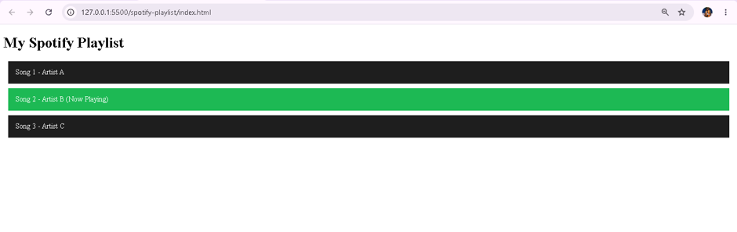

Q-5.Implement a simple light/dark mode switch for a BookMyShow movie detail page using internal CSS and a toggle button. When the button is clicked, switch between light and dark color themes for the page.<br><br><em><strong>Hint:</strong> Use JavaScript to add or remove a 'dark-mode' class on the <body> and define the color themes in CSS.</em>?
Ans.
<!DOCTYPE html>
<html lang="en">
<head>
<meta charset="UTF-8">
<meta name="viewport" content="width=device-width, initial-scale=1.0">

<title>BookMyShow Movie Details</title>
<style>
/* Light Mode */
body {
font-family: Arial, sans-serif;
background-color: white;
color: black;
margin: 0;
padding: 20px;
transition: 0.3s;
}
.movie-container {
max-width: 700px;
margin: auto;
padding: 20px;
border-radius: 10px;
background-color: #f5f5f5;
}
button {
background-color: #e23744;
color: white;
border: none;
padding: 12px 20px;
border-radius: 5px;
cursor: pointer;
font-size: 16px;
}
/* Dark Mode */
.dark-mode {
background-color: #121212;
color: white;
}
.dark-mode .movie-container {
background-color: #242424;
color: white;
}
.dark-mode button {
background-color: #555;
}
</style>
</head>
<body>
<button onclick="toggleDarkMode()">
Toggle Light / Dark Mode
</button>
<div class="movie-container">
<h1>Avengers: Endgame</h1>
<img src="avenger.jpg"
alt="Avengers Endgame Poster" height = "300px" width="300px">
<h2>Movie Details</h2>
<p><strong>Genre:</strong> Action, Adventure, Sci-Fi</p>
<p><strong>Duration:</strong> 3 Hours 1 Minute</p>
<p><strong>Language:</strong> English, Hindi</p>
<p>
Avengers: Endgame is an epic superhero movie where the Avengers
fight to restore the universe.
</p>
</div>
<script>
function toggleDarkMode() {
document.body.classList.toggle("dark-mode");
}
</script>
</body>
</html>
